QUERY:

select Z_durch_soll, Z_id, Z_status, Z_durch_ist, (((Z_durch_soll+0.2)-Z_durch_ist) / 2) AS Z_durch_delta, Z_durch_soll+0.2 AS Z_durch_korr
from Zylinder
where (Z_A_nr is NULL
AND Z_umfang = '900' AND Z_blaenge ='2340'
AND Z_durch_soll IN ('286.45','286.4','286.35','286.3','286.2','286.15','286.1','286.05')
AND Z_status = 'zcu'
AND (((Z_durch_soll+0.2)-Z_durch_ist) / 2) >= '0.085')
ORDER BY Z_durch_soll DESC, Z_durch_delta ASC

RESULT:

286,45 20703313 zcu 286,435 0,107507324218744 286,650012207031
286,45 20700408 zcu 286,435 0,107507324218744 286,650012207031
286,45 20703405 zcu 286,4 0,125009155273432 286,650012207031
286,45 20700206 zcu 286,21 0,220010375976557 286,650012207031
286,4 20700812 zcu 286,42 8,99902343749943E-02 286,599993896484
286,4 20700711 zcu 286,4 9,99999999999943E-02 286,599993896484
286,4 20703607 zcu 286,39 0,104989624023432 286,599993896484
286,4 20700610 zcu 286,384 0,107995605468744 286,599993896484
286,4 20700509 zcu 286,38 0,109994506835932 286,599993896484
286,4 20703506 zcu 286,38 0,109994506835932 286,599993896484
286,35 20700913 zcu 286,378 8,60076904296818E-02 286,550006103516
286,35 20701006 zcu 286,376 8,69995117187443E-02 286,550006103516
286,35 20701107 zcu 286,34 0,105004882812494 286,550006103516
286,35 20701208 zcu 286,322 0,114007568359369 286,550006103516
286,35 20703809 zcu 286,3 0,125009155273432 286,550006103516
286,35 20703708 zcu 286,228 0,161004638671869 286,550006103516
286,3 20703910 zcu 286,3 9,99999999999943E-02 286,499987792969
286,3 20701410 zcu 286,3 9,99999999999943E-02 286,499987792969
286,3 20701511 zcu 286,3 9,99999999999943E-02 286,499987792969
286,3 20701309 zcu 286,274 0,113000488281244 286,499987792969
286,3 20704012 zcu 286,24 0,129998779296869 286,499987792969
286,3 20701612 zcu 286,18 0,159997558593744 286,499987792969
286,2 20702008 zcu 286,198 0,101007080078119 286,400012207031
286,2 20801906 zcu 286,178 0,111001586914057 286,400012207031
286,2 20701713 zcu 286,17 0,114999389648432 286,400012207031
286,2 20704113 zcu 286,115 0,142510986328119 286,400012207031
286,2 20704205 zcu 286,09 0,155007934570307 286,400012207031
286,15 20704306 zcu 286,174 8,79913330078068E-02 286,349993896484
286,15 20702210 zcu 286,158 9,60021972656193E-02 286,349993896484
286,15 20702311 zcu 286,128 0,111001586914057 286,349993896484
286,15 20702412 zcu 286,115 0,117501831054682 286,349993896484
286,15 20702109 zcu 286,112 0,118997192382807 286,349993896484
286,15 20704407 zcu 286,042 0,154000854492182 286,349993896484
286,1 20702513 zcu 286,1 9,99999999999943E-02 286,300006103516
286,1 20702706 zcu 286,07 0,114999389648432 286,300006103516
286,1 20702605 zcu 286,056 0,122003173828119 286,300006103516
286,1 20704508 zcu 286,052 0,124002075195307 286,300006103516
286,05 20703010 zcu 286,04 0,104989624023432 286,249987792969

RESULT THAT I NEED:

286,45 20703313 zcu 286,435 0,107507324218744 286,650012207031
286,4 20703607 zcu 286,39 0,104989624023432 286,599993896484
286,4 20700610 zcu 286,384 0,107995605468744 286,599993896484
286,35 20700913 zcu 286,378 8,60076904296818E-02 286,550006103516
286,3 20704012 zcu 286,24 0,129998779296869 286,499987792969
286,3 20701612 zcu 286,18 0,159997558593744 286,499987792969
286,2 20704205 zcu 286,09 0,155007934570307 286,400012207031
286,15 20704407 zcu 286,042 0,154000854492182 286,349993896484
286,1 20702605 zcu 286,056 0,122003173828119 286,300006103516
286,1 20704508 zcu 286,052 0,124002075195307 286,300006103516
286,05 20703010 zcu 286,04 0,104989624023432 286,249987792969
MASK :

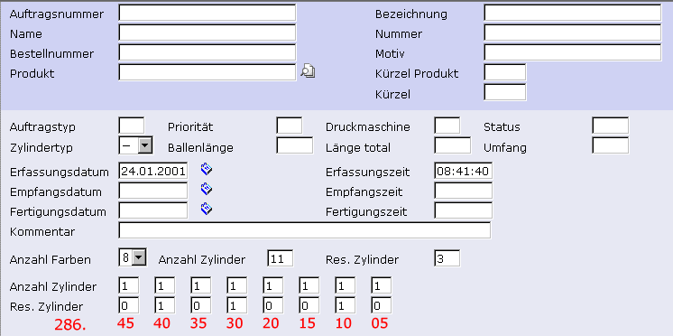

EXPLANATION :

In the mask You see the eight fields for zylinder and res. zylinder.
Each field has a diameter assigned (286.xx). The red diameters are physical values. What I need is to select the number of cylinders for each diameter from the db. This is done by trying with an incrementing offset (the 0.2 in the query). This offset needs to be the same for all the cylinders. So as soon as I have 1 cylinder for 286.45, the query should find 2 cylinders for 286.40 with the current offset and so on. How can I limit the number of records in the above query to have one entry for 286.45, two for 286.4, one for 286.35, two for 286.30 and so on ? The main thing is to find enough cylinders according to the mask with the smallest skin to be added.

